FL-01

AI Workflow Audit
and Tool Setup
  - General AI Fluency • Week 1 • Onboarding Phase

Participant | Ammar Kabeer
Program | BS Software Engineering
Internship | FlyRank AI Internship
Assignment | FL-01 | Estimated workload: 4 hours
Submission date | 23 July 2026

Purpose
To map my recurring weekly activities, decide where AI adds value, identify where human judgement must remain in control, and establish three reusable tasks for later assignments.

1. Personal Context
I am a BS Software Engineering student focused on Python, backend development, leetcode problums solver, Generative AI, AI automation, cloud technologies, and DevOps. My normal week includes university learning, programming practice, technical research, project planning, professional communication, and internship activities. This audit identifies how AI can support these tasks without replacing my learning, judgement, verification, or accountability.

2. Weekly Workflow Audit
Classification key: Just me = retained human responsibility • Delegate with review = AI drafts, I verify • Collaborate = iterative human-AI work • Fully automate = repeatable, low-risk process.
# | Recurring task | Classification | Rationale
1 | Attending lectures and understanding instructor expectations | Just me | I must personally listen, participate, and interpret course-specific guidance.
2 | Making final academic and career decisions | Just me | AI can show options, but the decision must reflect my goals, values, and circumstances.
3 | Learning Python and practising programming concepts | Collaborate with AI | AI can explain and provide hints, while I write and understand the code myself.
4 | Debugging Python or backend code | Collaborate with AI | AI can suggest causes and tests; I reproduce the issue and verify every correction.
5 | Doing leetcode problums | Delegate to AI with review | AI can perform a quick first review, but I decide which recommendations are valid.
6 | Summarising lecture notes and technical material | Delegate to AI with review | AI can condense material, but I compare the summary with the original source.
7 | Researching AI and backend technologies | Collaborate with AI | AI can organise questions and sources; I verify claims using credible primary material.
8 | Preparing FYP or semester-project proposals | Collaborate with AI | AI can improve structure, while the idea, feasibility, evidence, and decisions remain mine.
9 | Drafting professional emails and LinkedIn messages | Delegate to AI with review | AI can improve grammar and tone; I confirm facts, recipients, and intention before sending.
10 | Creating study quizzes from verified notes | Fully automate | With accurate source notes and a fixed format, question generation is repeatable and low-risk.
11 | Organising weekly study and internship priorities | Collaborate with AI | AI can propose a schedule, while I adjust it to my actual deadlines and energy.
12 | Drafting routine documentation from completed code | Delegate to AI with review | AI can draft descriptions efficiently; I confirm they match the implemented system.
13 | Running code formatters and automated tests | Fully automate | Rule-based tools can run consistently because expected standards and tests are predefined.
14 | Evaluating the quality of AI-generated output | Just me | I remain responsible for checking evidence, testing code, and identifying hallucinations.
15 | Submitting university or internship work | Just me | I must ensure the final work is accurate, original, complete, and suitable for submission.

3. Target Tasks for FL-02 to FL-04
I selected three frequent, testable tasks that represent coding, learning, and professional communication. Each task includes observable criteria for deciding whether AI-assisted work was done well.

Target Task 1 — Debug a Python Program
Specific task: Use AI to help diagnose and correct errors in a Python exercise or small backend program.
Done well means:
- The program passes all defined test cases.
- No new errors are introduced.
- I can explain the cause of the original error in my own words.
- I can explain why the correction works.
- The final code follows basic PEP 8 conventions.
- I run the code and verify the result instead of accepting the AI answer directly.

Target Task 2 — Solve LeetCode DSA Problems

Specific task: Use AI as a learning assistant to understand and solve LeetCode problems involving Data Structures and Algorithms.

Done well means:
- I understand the problem, inputs, outputs, and constraints before writing code.
- I attempt the problem independently before requesting a complete solution.
- I identify the relevant data structure or algorithmic pattern.
- The final solution passes all available test cases.
- I can explain the solution step by step in my own words.
- I correctly state its time and space complexity.
- I compare the basic approach with a more efficient solution.

Target Task 3 — Draft a Professional Message
Specific task: Use AI to draft an internship email, LinkedIn message, or professional response.
Done well means:
- The message has a clear purpose and an appropriate subject line when needed.
- An email is approximately 80–150 words unless the context requires otherwise.
- Names, roles, dates, and other details are accurate.
- There are no noticeable grammar or spelling errors.
- The tone is polite, concise, natural, and professional.
- I personalise and approve the message before sending it.

4. Free Toolkit and Course Setup
ChatGPT: Account created or confirmed and ready for use.
Claude: Account created or confirmed and one Project configured.
Anthropic Academy: Enrolled in AI Fluency: Framework & Foundations.
Course progress: At least Module 1 completed before final submission.

5. Claude Project Configuration
Project name: backend AI and Software Engineering Workspace

6. Evidence of Completion

Evidence 1 — Configured Claude Project
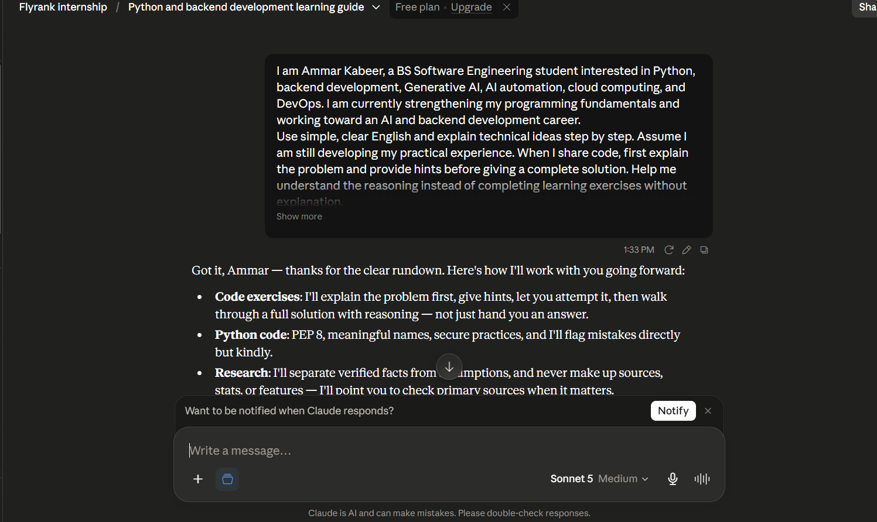

Evidence 2 — Anthropic Academy Enrolment
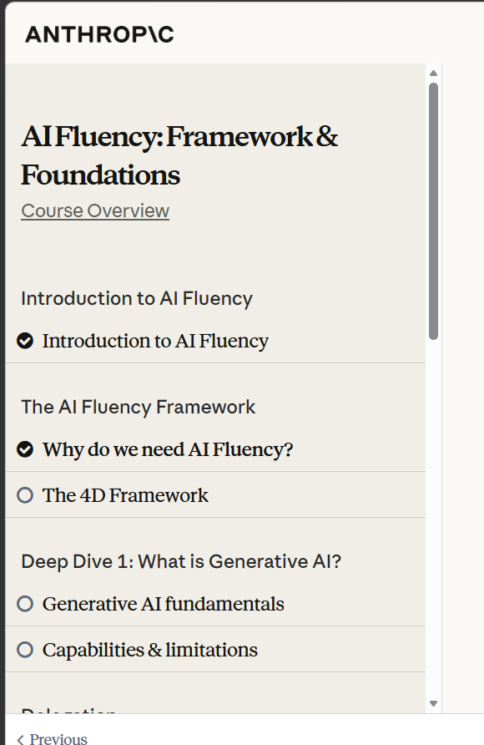

6. Evidence of Completion (continued)
Evidence 3 — Module 1 Completion
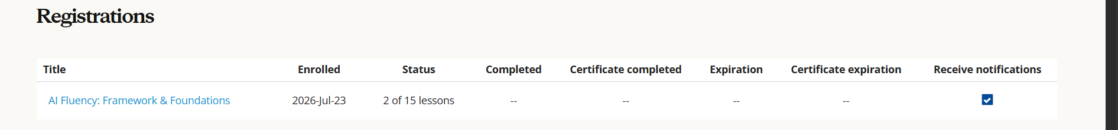
.
Evidence 4 — Tool Accounts (if separately required)
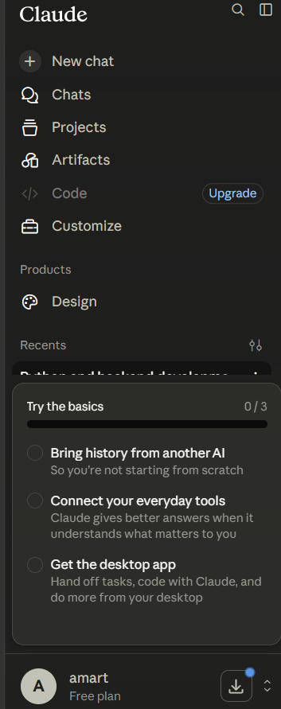
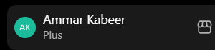

7. Reflection
This audit showed me that AI is most valuable for creating initial drafts, explaining difficult concepts, reviewing code, and organising information. However, it should not replace my learning, personal decisions, source verification, or responsibility for submitted work. I will use AI as a supervised assistant by providing clear context, reviewing its output, testing technical suggestions, and remaining accountable for the final result.

